# CS 255 System Design Document Template

This template lays out all the different sections that you need to complete for Project Two. Each section has guidance to prompt your thinking. You will need to continually reference the interview transcript as you work to make sure that you are addressing your client’s needs. There is no required length for the final document. Instead the goal is to complete each section based on what your client’s needs are. Remove this note when you are finished, and replace all bracketed text with the relevant information.

## UML Diagrams

### UML Use Case Diagram

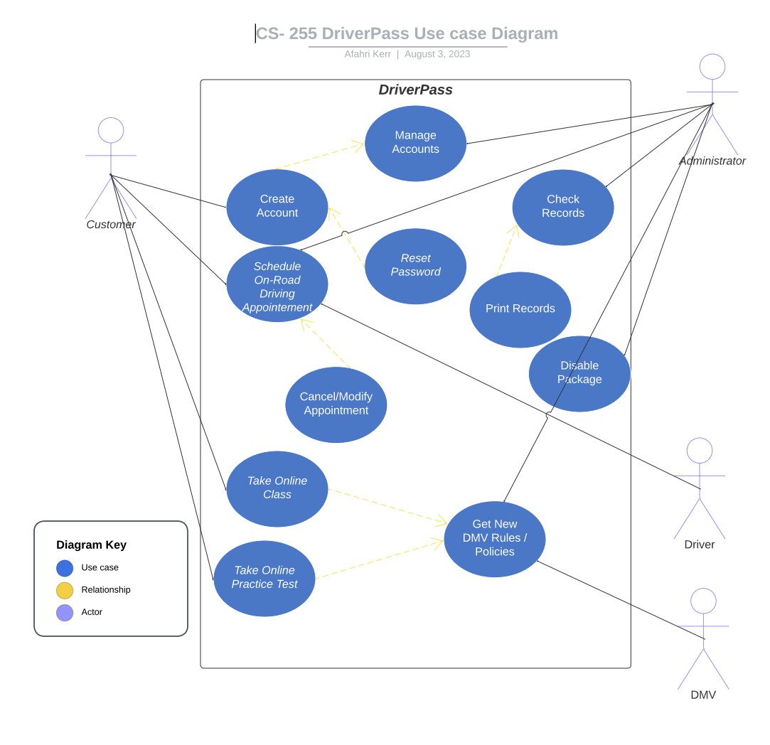

### UML Activity Diagrams

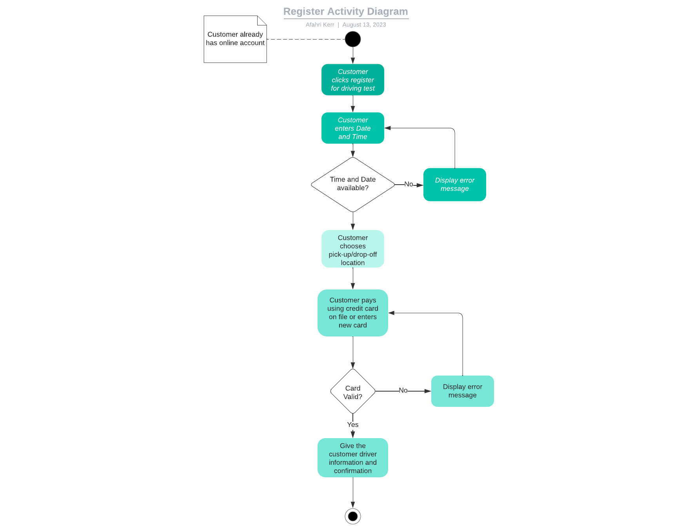

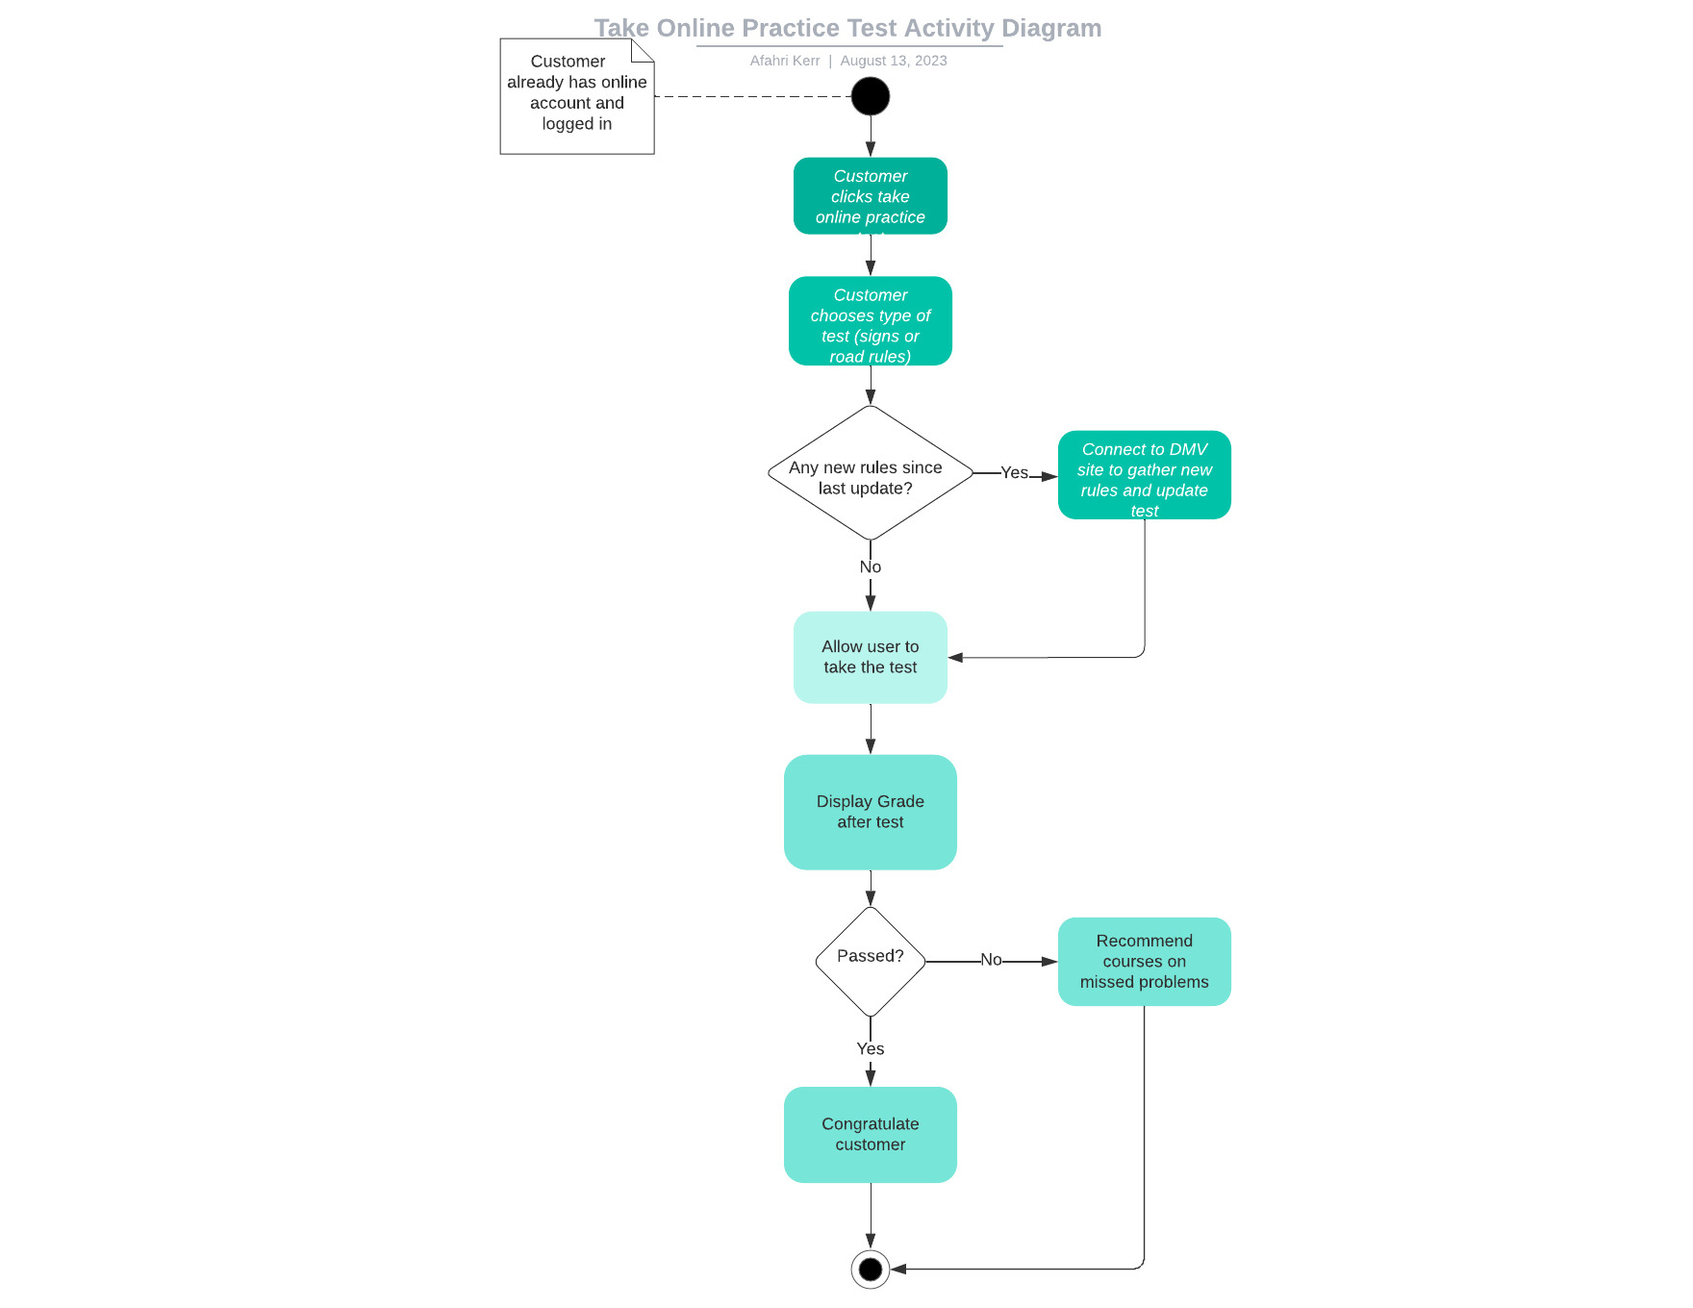

### UML Sequence Diagram

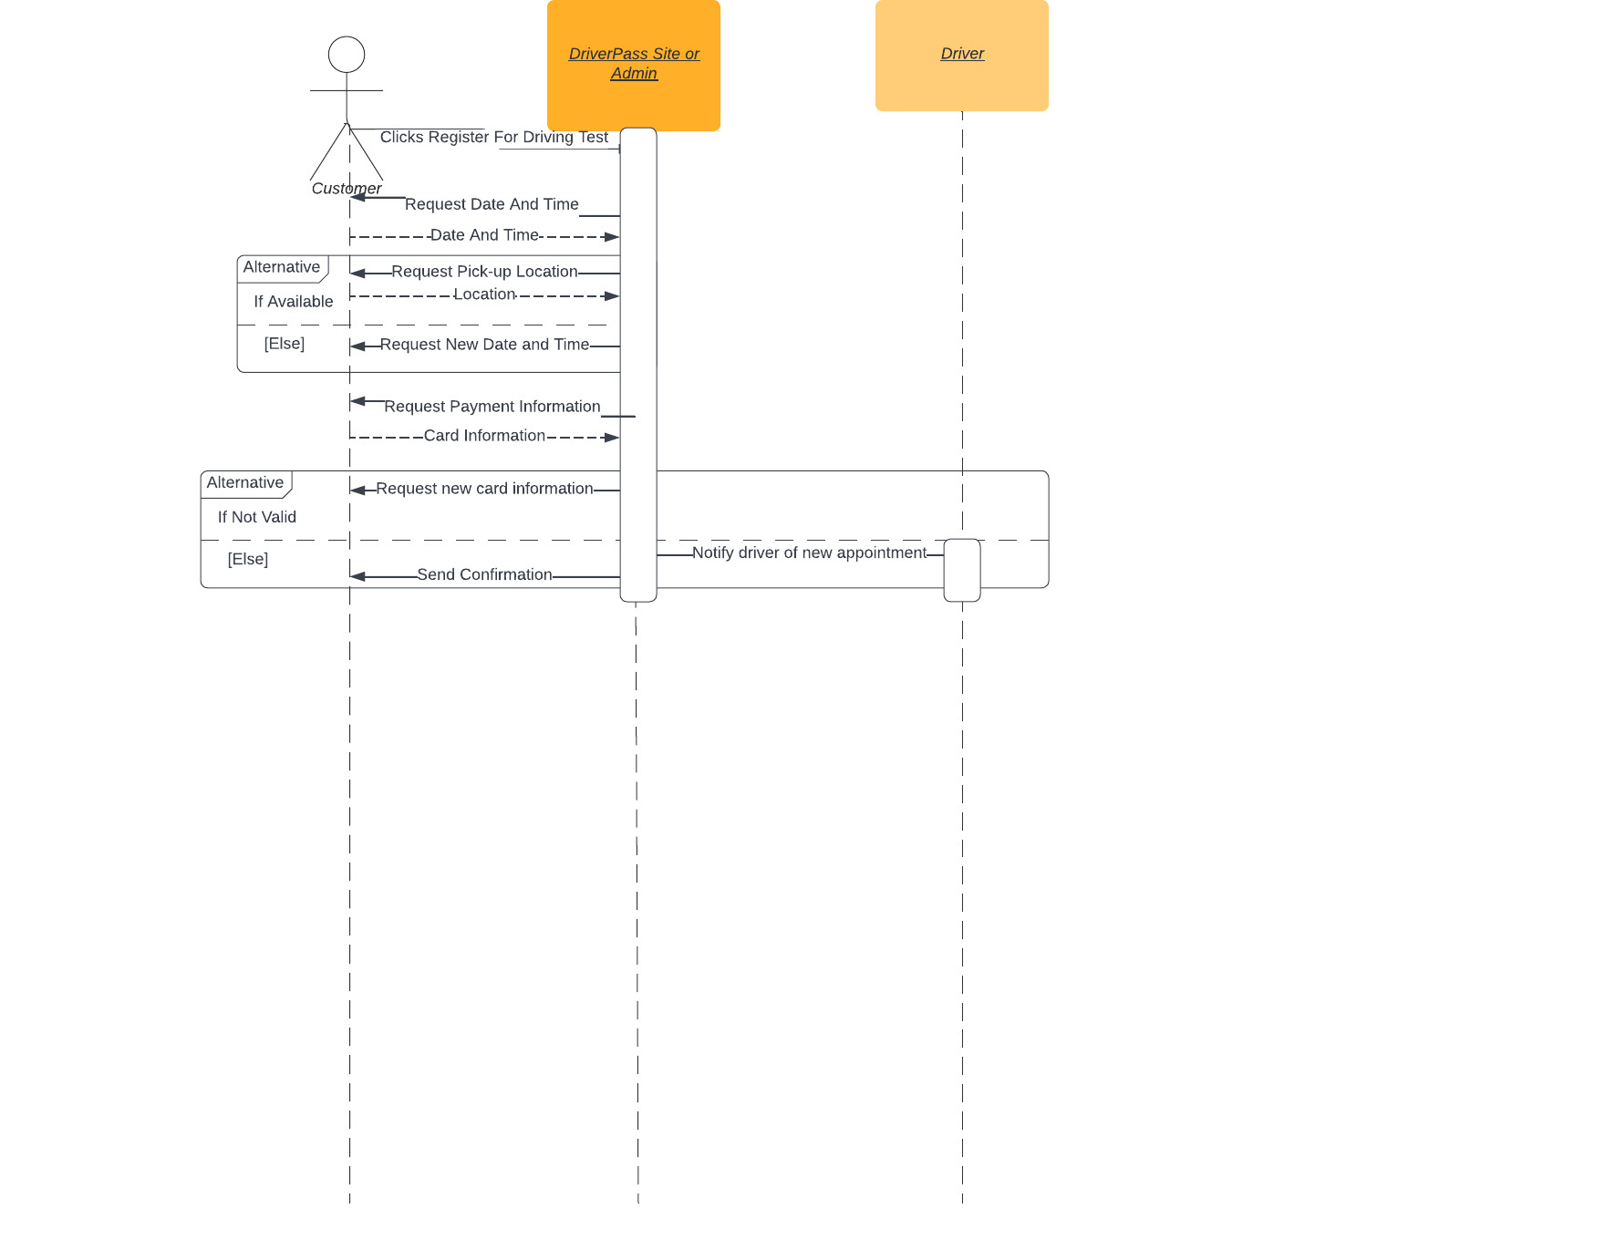

### UML Class Diagram

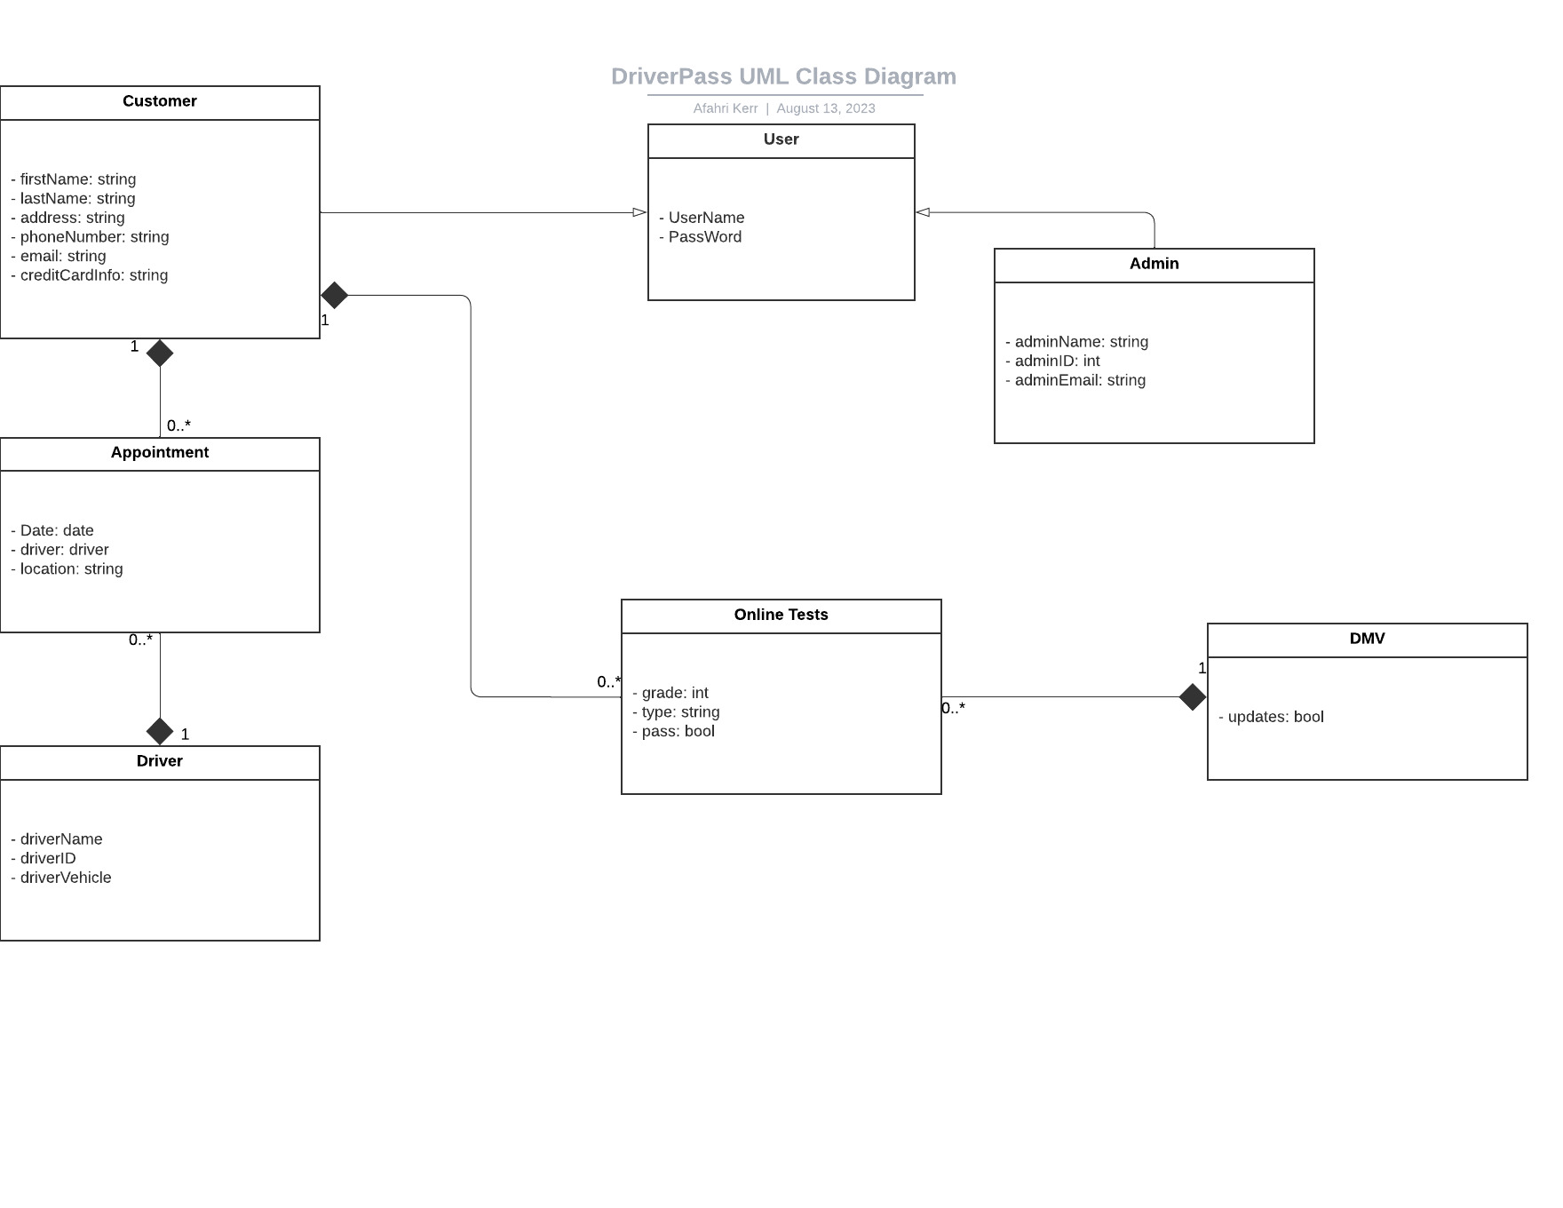

## Technical Requirements

*The system will have a few requirements. First, a user will need a device with internet access. The device will also need to be capable of making an HTTPS connection. The system will be running on the cloud to allow for 24/7 access. This will also allow for heavy traffic on the system. We will need a database to hold all of the customers data. It will also need to be connected to the DMV to allow for updates to online tests.*